Lösungen
2 LISTENING Chores
15
12
8
10
 | Harry | Beth | Mrs Barrow’s  son Peter | Cathy
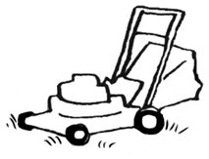
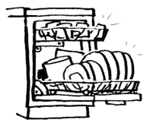
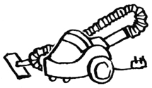
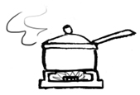
£

Hörverstehenstext
2 LISTENING Chores
►7

Presenter: Hello, there. This week I’m talking to students and teachers about chores and pocket money. How much pocket money do teenagers get? And do they help out at home? First I have Harry here with me. Hi, Harry.
Harry: Hi.
Presenter: Harry, do you do chores at home?
Harry: Yes, I do. Every week I cut the grass in the garden and I always help my mom after dinner. I empty and fill the dishwasher. It’s not much fun, but it’s OK.
Presenter: And do you get pocket money?
Harry: Yes – I get £10 a week. My sister is older than me so she gets a bit more. I don’t think that’s fair!
Presenter: Thanks, Harry. Now we’ve Beth here with us. Now, you don’t get any pocket money, is that right, Beth?
Beth: Hi, there. Yes, that’s right. I don’t get any pocket money from my parents, but I do a paper round at the weekends. It’s only a small round – I get about £8 a week for it.
Presenter: And what about at home? Do you do chores?
Beth: Well, I’m not lazy! I fill the dishwasher in the evenings, but I don’t do any other chores. I think I’m lucky!
Presenter: Thanks, Beth. What does an adult think? I’m going to talk to Mrs Barrows. She has a teenage son. Mrs Barrows, is Beth lucky?
Mrs Barrows: I think so, yes. My son Peter does chores at home. He hoovers the house and helps me in the kitchen when I’m cooking dinner. I think it’s important for young people to help at home.
Presenter: Does Peter have a job, Mrs Barrows?
Mrs Barrows: No, he doesn’t have a job. I think he should focus on his homework in his free time. I give him pocket money – £12 a week.
Presenter: £12 a week – that sounds good.
Mrs Barrows: £12 a week only if he does his homework and his chores.
Presenter: OK, thanks, Mrs Barrows. Cathy, £12 a week pocket money. Does that sound good to you?
Cathy: Yeah, not bad. I get £15 a week.
Presenter: And do you have to do chores at home?
Cathy: I don’t have to do chores, but I like helping my parents. Sometimes I cut the grass in the garden and sometimes I hoover the living-room.
Presenter: Right, well we’ve run out of time this week. It’s been interesting to hear about different people’s chores and pocket money. Next week we’ll be talking about hobbies.

