16 LANGUAGE What is class 8 PR going to do on the class trip? / 9
More help: -3
The teacher is telling the students what they’re going to do on their class trip next week.
Write down what he says:
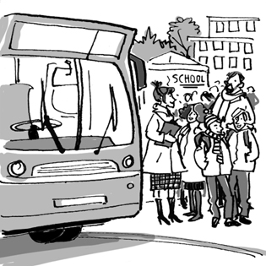
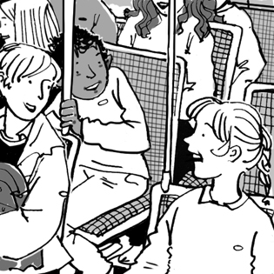
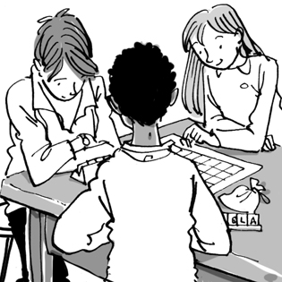
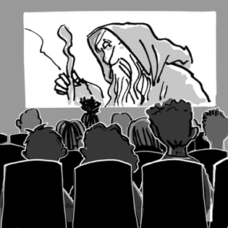
1 |  |  | 2 |  |  | 3 |  |  | 4
Monday |  |  | Then |  |  | Tuesday morning |  |  | Tuesday afternoon
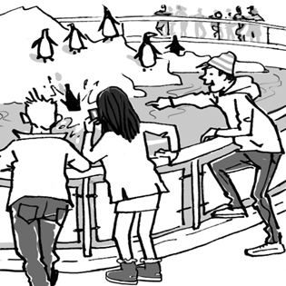
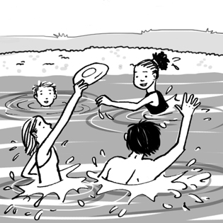
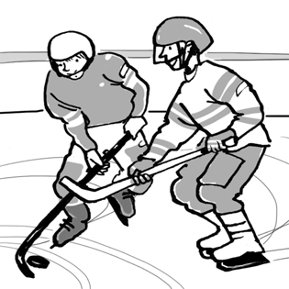
5 |  |  | 6 |  |  | 7
Wednesday morning |  |  | Wednesday afternoon |  |  | Wednesday evening

1
On Monday morning we’re going to meet at school.
2
3
4
5
6
7
… and on Thursday morning we’re going to go back home.

